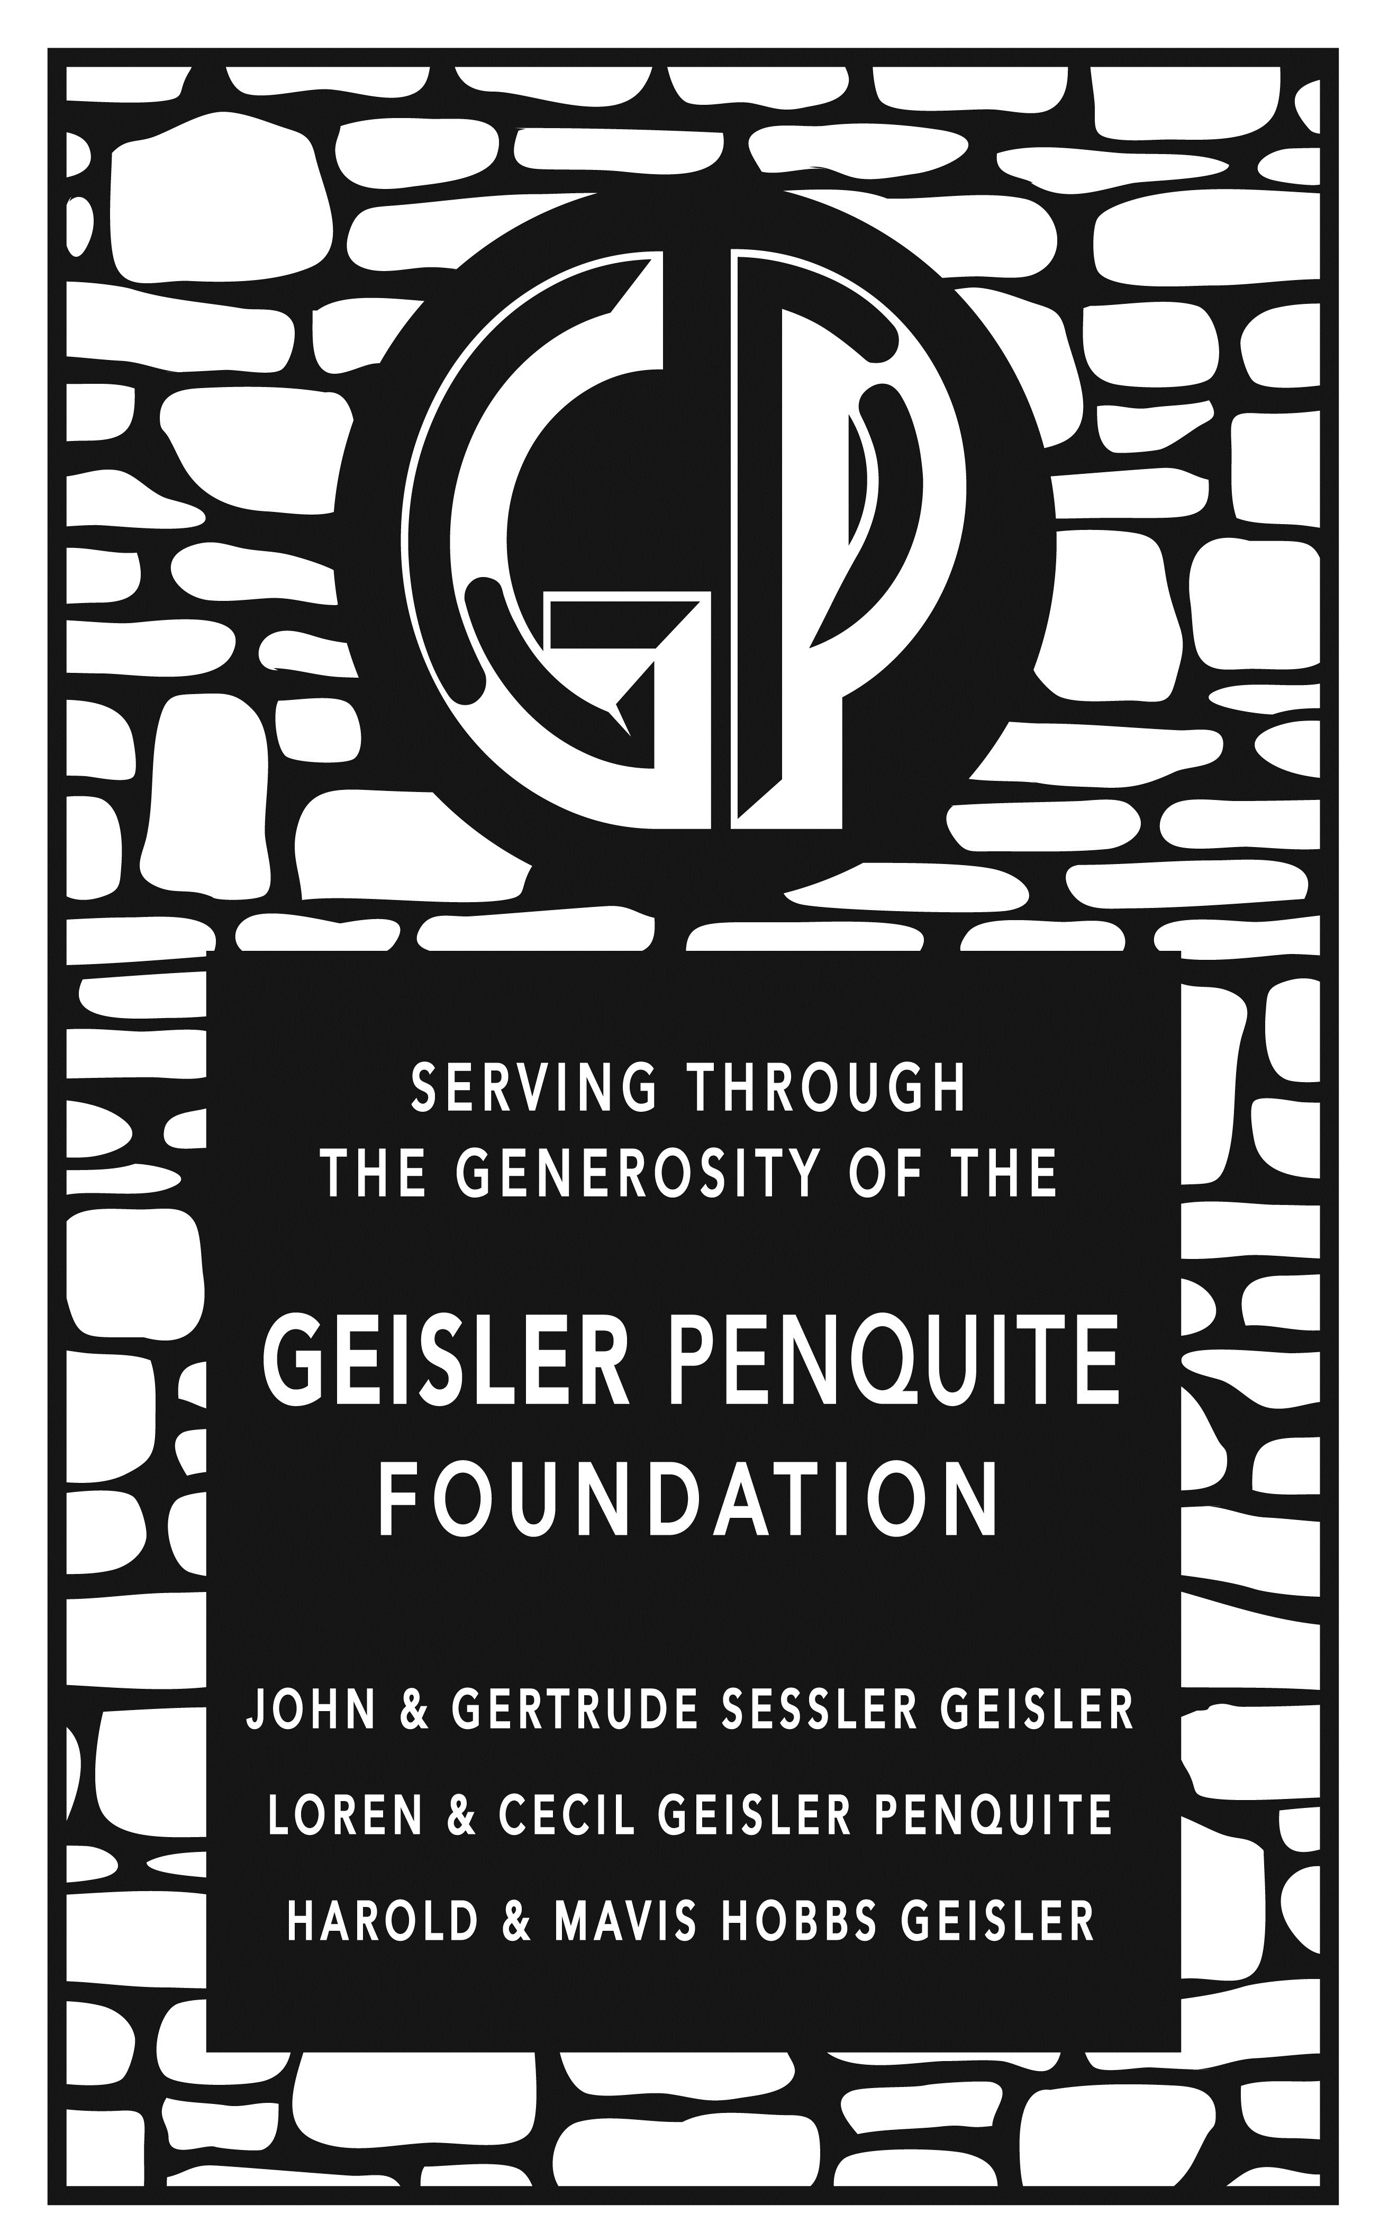
Geisler-Penquite Foundation
The Geisler-Penquite Foundation’s Educational Excellence programming was established in 2011 to enhance educational opportunities in teacher preparation and performance. The Educational Excellence programming is hosted and completely facilitated by the Education Department of Central College.

Funding
The Geisler-Penquite Committee is initiating support for professional development opportunities for students in the Education Program at Central College by providing $100 scholarship awards to Education students seeking to further their educational experiences. Money will be allocated from the Geisler-Penquite Excellence in Education fund.

Examples of professional development opportunities include, but are not limited to:
- Registration fees for educational conference attendance
- Travel for expenses related to attendance at educational conferences
- Registration/tuition fees for educational coursework outside of the typical Central College and State of Iowa requirements (i.e. AEA courses; online professional development offerings by state, national agencies, sign language courses, crisis prevention courses, etc)
- Travel with faculty to international or culturally diverse educational experiences

Consideration Factors for Funding
It is not the intent of the committee to simply offset travel expenses for students. Rather, the committee expects sharing of ideas and strategies learned from the travel, course or experience. You should be SPECIFIC as to how this will benefit you as a pre-service teacher. Professionalism is expected and denials of funding may be made based on lack of professional submission/explanations. Incomplete applications will not be accepted. All recipients will be expected to give a presentation to peers and interested parties as to how the experience, travel or course shaped their development as a pre-service teacher. This will most likely occur during the annual Education Department Senior Showcase event.

Process
You must be admitted into the Education Program to be eligible for these funds. Please complete the attached application and submit to Dr. Jennifer Diers, chair of the Geisler-Penquite Committee, at least 4 weeks prior to your expected need for funding. Special requests may be considered if this time frame cannot be met, however the committee would like to sustain a four week review process if possible. If for some reason funding is provided and cannot be used for the specified experience, you affirm the obligation for you to return the funds to the Geisler-Penquite Professional Development Fund immediately.
APPLICATION FOR FUNDING:

Student Name: | Student Central ID number:
Year in School:

Elementary or Secondary Education/Major:

Admitted to the Education Program?
° Yes °No (Note, if you are not admitted to the education program, you are not eligible for funding)
Conference title, course title, travel experience, etc.:

Date(s) & Location of experience/course/conference:

Approximate overall total cost of your experience/course/conference:

*Please note the maximum you can receive from this fund is $100.00
Amount you are requesting from this fund (maximum $100):

Provide a detailed explanation as to why this experience will enhance your development as a pre-service teacher. What specifically will you be involved with, participating in or attending? Specifically how will this improve your personal development as a pre-service teacher?

As a part of this application you need a faculty member from Central College to support and
sign as confirmation of your involvement in this opportunity.

Faculty Name:

Faculty Email & Campus Phone:

By signing this document, you affirm that this student is in fact registered or committed to involvement in the above stated experience and that this experience will support the student’s overall educational
development as a pre-service teacher.

_______________________________________________ _____________________
Faculty Signature Date

Student Signature:

By signing this document, you affirm that you are in fact registered or committed to involvement in the
above stated experience and that this experience will support your overall educational development as a
pre-service teacher. Additionally, you are committing to a public presentation during the Education Program Senior Showcase regarding your involvement in this experience. If for some reason funding is provided and cannot be used for the specified experience, you affirm the need for you to return the funds to the Geisler-Penquite Professional Development Fund immediately

_______________________________________________ _____________________
Student Signature Date

FOR COMMITTEE USE ONLY (do not write below this line)
Review Date:
Approval or Denial Date & Action:
Check Request Date:
Check Disbursement Date:
Notification of presentation date:

