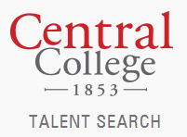
Educational Talent Search

Event Schedule 2015 - 2016
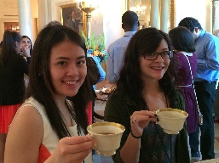  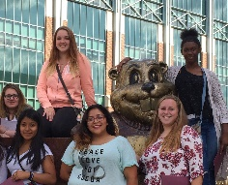  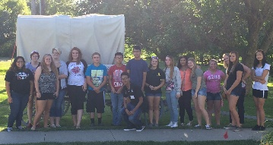 | Events are a great way to Visit Colleges and Universities in Iowa and nearby states, Meet New People, Experience Cultural Events, and so much more. Applications are distributed at meetings or mailed prior to the event and are always available at the ETS website, www.central.edu/talentsearch. Students are selected to attend based on meeting and school attendance and grades.

EVENT NAME | DATE | GRADES ELIGIBLE | DESCRIPTION | APPLICATION DUE DATE
FRESHMEN DAY | 9.26.2015 | 9TH | FRESHMEN ARE INVITED TO CENTRAL FOR A FUNFILLED DAY | 9.14.2015
JUNIOR/SENIOR VISIT TO UNI | 10.1.2015 | 11TH & 12TH | A CHANCE TO VISIT THE UNIVERSITY OF NORTHERN IOWA | 9.18.15
HIATT/HOYT COLLEGE VISIT | 10.15.15 | 8TH | 8TH GRADE STUDENTS FROM HIATT AND HOYT WILL VISIT THE UNIVERSITY OF IOWA | 10.1.15
OSKY/EBF COLLEGE VISIT | 10.20.15 | 8TH | 8TH GRADE STUDENTS FROM OSKALOOSA AND EBF WILL VISIT THE UNIVERSITY OF IOWA | 10.6.15
JUNIOR/SENIOR PARENT DAY | 10.24.15 | 11TH & 12TH | 11TH AND 12TH GRADE STUDENTS AND THEIR PARENTS ARE INVITED TO LEARN ABOUT PREPARING FOR COLLEGE | 10.9.15
THE ILLUSIONIST | 10.25.2015 | 9TH-12TH | STUDENTS WILL HAVE THE OPPORTUNITY TO SEE A MAGIC SHOW AT THE CIVIC CENTER | 10.7.2015
HARDING/WOODSIDE COLLEGE VISIT | 10.29.2015 | 8TH | 8TH GRADE STUDENTS FROM HARDING AND WOODSIDE WILL VISIT THE UNIVERSITY OF NORTHERN IOWA | 10.7.2015
WEEKS/MCCOMBS COLLEGE VISIT | 11.3.2015 | 8TH | 8TH GRADE STUDENTS FROM WEEKS AND MCCOMBS WILL VISIT THE UNIVERSITY OF IOWA | 10.19.2015
NEWSIES | 1.16.2016 | 9TH-12TH | SEE A BROADWAY SHOW AT THE CIVIC CENTER | 12.28.2015
FRESHMEN RETREAT | 2.25/26.2016 | 9TH | AN OVERNIGHT RETREAT AT CENTRAL COLLEGE | 2.5.2016
HARDING/WOODSIDE COLLEGE VISIT | 3.31.2016 | 7TH | 7TH GRADE STUDENTS FROM HARDING AND WOODSIDE WILL VISIT A PRIVATE COLLEGE IN IOWA | 3.11.2016
OSKALOOSA/EBF COLLEGE VISIT | 4.21.2016 | 7TH | 7TH GRADE STUDENTS FROM OSKALOOSA AND EDDYVILLE WILL VISIT A PRIVATE COLLEGE IN IOWA | 4.1.2016
HIATT/HOYT COLLEGE VISIT | 4.26.2016 | 7TH | 7TH GRADE STUDENTS FROM HIATT AND HOYT WILL VISIT A PRIVATE COLLEGE IN IOWA | 4.8.2016
MCCOMBS/WEEKS COLLEGE VISIT | 5.3.2016 | 7TH | 7TH GRADE STUDENTS FROM MCCOMBS AND WEEKS WILL VISIT A PRIVATE COLLEGE IN IOWA | 4.15.2016

September | October | November | December | January | February
S M T W T F S  1 2 3 4 5  6 7 8 9 10 11 12  13 14 15 16 17 18 19  20 21 22 23 24 25 26  27 28 29 30 | S M T W T F S  1 2 3  4 5 6 7 8 9 10  11 12 13 14 15 16 17  18 19 20 21 22 23 24  25 26 27 28 29 30 31 | S M T W T F S  1 2 3 4 5 6 7  8 9 10 11 12 13 14  15 16 17 18 19 20 21  22 23 24 25 26 27 28  29 30 | S M T W T F S  1 2 3 4 5  6 7 8 9 10 11 12  13 14 15 16 17 18 19  20 21 22 23 24 25 26  27 28 29 30 31 | S M T W T F S  1 2  3 4 5 6 7 8 9  10 11 12 13 14 15 16  17 18 19 20 21 22 23  24 25 26 27 28 29 30  31 | S M T W T F S  1 2 3 4 5 6  7 8 9 10 11 12 13  14 15 16 17 18 19 20  21 22 23 24 25 26 27  28 29
March | April | May | June | July | August
S M T W T F S  1 2 3 4 5  6 7 8 9 10 11 12  13 14 15 16 17 18 19  20 21 22 23 24 25 26  27 28 29 30 31 | S M T W T F S  1 2  3 4 5 6 7 8 9  10 11 12 13 14 15 16  17 18 19 20 21 22 23  24 25 26 27 28 29 30 | S M T W T F S  1 2 3 4 5 6 7  8 9 10 11 12 13 14  15 16 17 18 19 20 21  22 23 24 25 26 27 28  29 30 31 | S M T W T F S  1 2 3 4  5 6 7 8 9 10 11  12 13 14 15 16 17 18  19 20 21 22 23 24 25  26 27 28 29 30 | S M T W T F S  1 2  3 4 5 6 7 8 9  10 11 12 13 14 15 16  17 18 19 20 21 22 23  24 25 26 27 28 29 30  31 | S M T W T F S  1 2 3 4 5 6  7 8 9 10 11 12 13  14 15 16 17 18 19 20  21 22 23 24 25 26 27  28 29 30 31
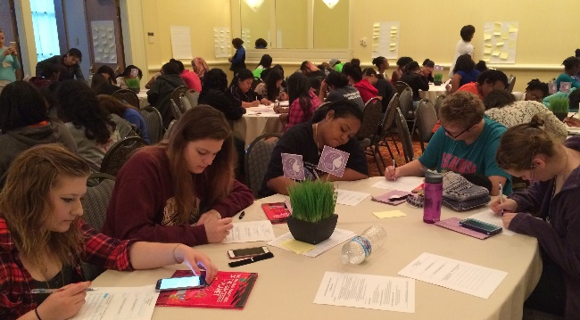
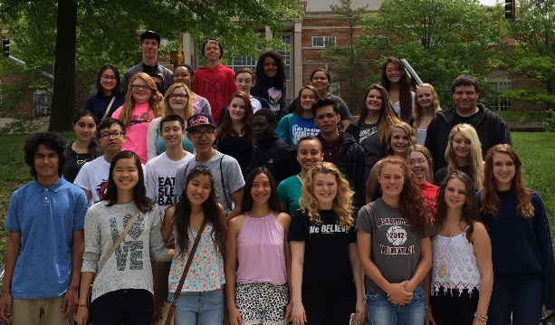
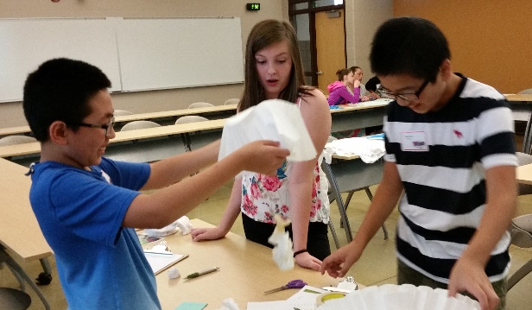
If you have any questions regarding ETS events, please contact the office at 1.800.527.4047.
Additional information for each event will be distributed with event applications.

